

Daffodil International University

Department of Computer Science and Engineering

Faculty of Science and Information Technology (FSIT)

Final Examination, Semester: Fall-2017

Course Code: CSE311 Course Title: Database Management Systems

Section: ALL Course Teacher: ALL

Time: 120 minutes Answer all questions Total Marks: 40

|  |
| --- |
| **Q1:** Consider the following schema for a database where the primary keys are given. Give an expression in **SQL** for each of the queries. **12**    Person(Nid, pname, age)  Hotels(hid, hname, location, rating, revenue)  Reserves(Nid, hid, day)   1. ***Find all information of Persons who have reserved Hotel entitled as “ Sundarban”*.** 2. ***Find the name and the age of the youngest person in the Person table.*** 3. ***Find the average revenue of hotels for each rating level.*** 4. ***Find the names and locations of Hotel whose rating is better than some hotel called “Hotel Sonargaon”.*** 5. ***Create a view showing all the Persons ID who have reserved a hotel at “DHAKA” or a hotel at “CHITTAGONG”.*** 6. ***Add a new column in Person table name “Email” and allocate 10 variable size character to it.*** |
| **Q2:** Answer the following questions  1.PNG   1. Write down the algebraic expression to transform the Table 1 to Table 2 0**2**   2.PNG   1. Consider the above tables. Now, Which of the following relational algebra expressions are syntactically correct? What do they mean? 0**4**   **i)**  **ii)**  **iii)**  **iv)**  **v)** |
|  |

**Q3:** Consider the following relational schema and normalize it up to third normal form. Be certain to indicate necessary constraints.**07**

|  |  |  |  |  |  |  |  |
| --- | --- | --- | --- | --- | --- | --- | --- |
| StudentId | Student_Name | Birth Year | City | ZipCode | Subject | Teacher | Grade |
| 68646S | Samina | 1996 | Dhaka | 1207 | English  Math  Physics | AIk  JHU  SKl | B  A-  A |

**Q4:** Consider the following schemas: **06**  
 lives(person-name,street,city)

works(person-name, company-name,salary)

located-in(company-name,city)

manages(person-name,manager-name)   
Give an expression in the **relational algebra** to answer each of the queries.

1. ***Find the name and city of all employees who work for City Bank.***
2. ***Find all persons who do not work for City Bank.***
3. ***Find the name, street and city of all employees who work for City Bank and earn more than 35000 Bdt.***

**Q5:** Consider the following code snippet:   
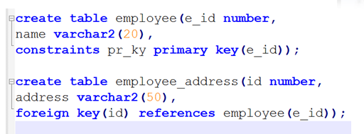  
Now what will be the output of the following command? **03**

**Drop table employee;**

**Q6:**  a) Define Database Transaction. Write the advantages of COMMIT and ROLLBACK.**03**

b) What is deadlock? Describe some way to avoid Deadlock. **03**